Digital Dividends? Rural E-Commerce and the Urban-Rural Income Gap
Lei Wang and Yongming Sun
We examine the impact of China’s Rural E-Commerce Comprehensive Demonstration (RECD) project on the urban-rural income gap. Using county-level data from 2006 to 2022 and a time-varying difference-in-differences design, we find that participation in the RECD project led to a significant reduction in urban-rural income disparity. The effects were especially pronounced in less-developed regions, poverty-designated counties, and areas with weaker digital infrastructure, and gains were disproportionately concentrated among rural households. These “biased” digital dividends contrast with market-driven e-commerce development, such as Taobao Villages, which tended to exacerbate inequality.

Summary
China’s rapid economic growth has been shadowed by a persistent urban-rural divide. The average disposable income of urban residents is still more than twice that of rural residents, a structural imbalance that challenges the country’s pursuit of “common prosperity.” As digital technologies reshape economies worldwide, a central question arises: can the spread of rural e-commerce (REC) reduce inequality, or does it risk amplifying the advantages of already better-connected regions?
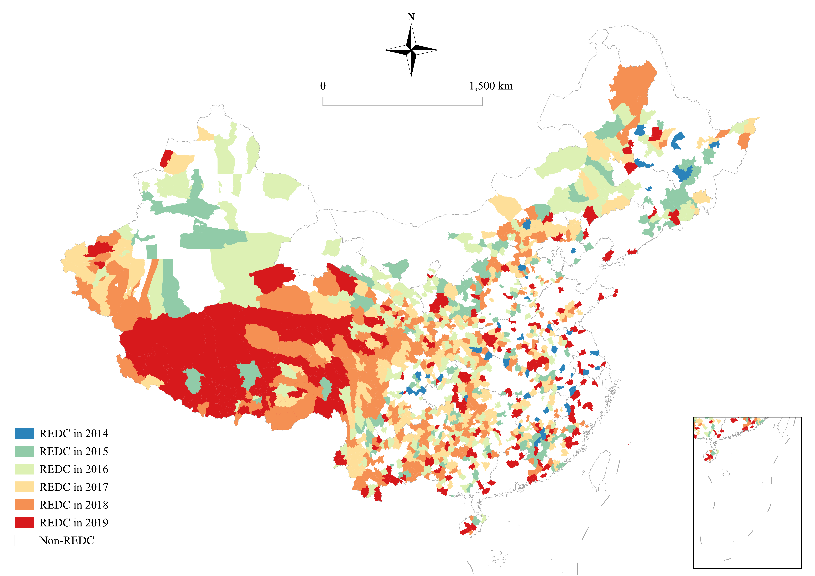
Figure 1. Spatial distribution of RECD pilot counties
Notes: This map shows the counties selected for the Rural E-Commerce Comprehensive Demonstration (RECD) project. Pilot counties are disproportionately concentrated in China’s less-developed central and western regions, in contrast to the peri-urban clustering of market-driven Taobao Villages.

Some evidence points to the latter. Studies of so-called Taobao Villages (TBVs)—grassroots clusters of e-commerce activity—suggest that while they have boosted local incomes, their benefits are concentrated in peri-urban areas with stronger industrial bases. Because TBVs often emerge from the relocation of urban industries, they can reinforce disparities rather than reduce them (Tang and Zhu 2020, Liu and Zhou 2023). These experiences echo a broader concern highlighted in the digital divide literature: new technologies often generate uneven benefits that favor better-endowed regions and early adopters (Juhász 2018). This has fueled a policy debate: should REC be left to evolve organically, or does it require government guidance to ensure its benefits reach disadvantaged areas?

Table 1. Comparison of Taobao Villages and the RECD project
REC models | Spatial distribution | Policy objectives | Income effect | Urban-rural income gap
TBVs (Market-oriented REC development) | Peri-urban villages in China’s economically advanced eastern provinces. | No explicit policy objectives identified. | Contributes to increased income for both urban and rural populations (Tang et al. 2022). | Exacerbates the urban-rural income disparity due to industrial specialization and urbanization processes (Liu and Zhou 2023).
RECD project (Policy-oriented REC development) | Counties within less-developed regions of China, covering 832 poverty-stricken counties. | Aims to promote agricultural product commercialization, foster high-quality rural economic growth, and mitigate the urban-rural divide. | Positively impacts rural household income, with a disproportionately beneficial effect on vulnerable, low-income rural populations (Sun et al. 2025). | Ameliorates the income gap through enhanced rural income generation.
Notes: This table contrasts two models of rural e-commerce. Taobao Villages, emerging organically in peri-urban eastern provinces, boosted incomes but widened disparities. By contrast, the policy-driven RECD project targeted disadvantaged counties, raised rural household incomes, and reduced the urban-rural income gap.
To address this question, our recent study turns to China’s Rural E-Commerce Comprehensive Demonstration (RECD) project, launched in 2014. Unlike TBVs, the RECD project is a top-down initiative that deliberately targets less-developed and poverty-stricken counties. Following an initial pilot phase that identified replicable models based on existing REC infrastructure, the project strategically prioritized less developed regions, particularly officially designated poverty counties, between 2015 and 2019. During this period, selection criteria favored nationally recognized poverty counties meeting specific developmental needs. As a result, the spatial distribution of the RECD pilot counties is heavily skewed toward China’s less developed central and western regions (Figure 1). Its design is ambitious: establishing county-level logistics hubs and village service stations, subsidizing training in digital skills, and promoting the sale of local agricultural products. Backed by over 20 billion yuan in funding from the central government, the program created more than 2,700 county-level centers and 1.58 million village-level stations by 2022, reducing “last-mile delivery” barriers and generating an eleven-fold increase in rural online sales between 2014 and 2022.

Figure 2. Rural online retail sales, 2014–2022
Notes: Rural online retail sales expanded more than elevenfold between 2014 and 2022, rising from 0.18 trillion yuan to 2.17 trillion yuan. The surge coincides with the rollout of the RECD project, which created logistics hubs and service stations that reduced “last-mile delivery” barriers.

Drawing on county-level data from 2006 to 2022, we employ a time-varying difference-in-differences framework to evaluate the RECD’s impact on the urban-rural income gap (Ji et al. 2023, Wei et al. 2024). The results are striking. On average, counties participating in the program experienced a 0.079 reduction in the ratio of urban-to-rural incomes relative to non-participating counties. Our regression results remain robust under a series of robustness checks. Furthermore, this effect is especially pronounced in less-developed regions, poverty-designated counties, and areas with weak digital infrastructure. In short, while market-driven REC has often heightened inequality, policy-driven REC has measurably narrowed the divide.

Table 2. Effect of RECD on the urban-rural income gap
Variables | Gap
Variables | (1) | (2) | (3)
DID | -0.092*** | -0.080*** | -0.079***
DID | (0.015) | (0.015) | (0.015)
Constant | 2.454*** | 5.513*** | 5.529***
Constant | (0.003) | (0.467) | (0.468)
Controls | No | Yes | Yes
S*Year dummy | No | No | Yes
FE | Yes | Yes | Yes
Obs | 18,712 | 18,712 | 18,712
R-squared | 0.865 | 0.866 | 0.867
Notes: This table reports baseline regression results. Participation in the RECD project reduced the urban-rural income ratio by 0.079 on average, confirming that targeted, policy-driven e-commerce development narrowed income disparities across counties.
Understanding how this happens is crucial. Our mechanism analysis shows that the RECD program generates what we term “skewed digital dividends.” Specifically, rural residents experience disproportionately greater gains in both income and employment. Rural household incomes increased by about 1.3% on average, while the impact on urban incomes was negligible. At the same time, rural employment rates rose by 2.2%, driven by new opportunities in logistics, warehousing, and online sales, whereas urban employment saw no significant change. These biased income and employment effects explain why the program reduces the income gap rather than exacerbating it.

Table 3. Mechanisms: Income and employment effects
Variables | lnci |  | lnri | cwork |  | rwork
Variables | (1) | (2) |  |  | (3) |  | (4)
DID | 0.007 | 0.013*** |  |  | -0.002 |  | 0.033**
DID | (0.011) | (0.003) |  |  | (0.003) |  | (0.014)
Constant | 8.314*** | 6.928*** |  |  | -0.105 |  | 1.566***
Constant | (0.133) | (0.131) |  |  | (0.149) |  | (0.416)
Controls | Yes | Yes |  |  | Yes |  | Yes
FE | Yes | Yes |  |  | Yes |  | Yes
Obs | 18,712 | 18,712 |  |  | 3,415 |  | 7,575
R-squared | 0.976 | 0.986 |  |  | 0.866 |  | 0.593
Notes: This table shows the “biased” digital dividends of the RECD project. Rural household incomes rose by about 1.3% and rural employment rates increased by 3.3%, while corresponding urban gains were negligible. These asymmetric benefits explain why the program narrowed the income gap.
The policy’s impact is also visible in case studies. In Jiangyong County, Hunan Province, local farmers were able to market specialty products such as pomelos and taro online, generating over 230 million yuan in sales and boosting household incomes by 4,000 yuan annually. In Zhenxiong County, Yunnan Province, the program directly created more than 3,000 jobs and engaged hundreds of thousands of rural workers in related activities. These examples illustrate how targeted support for agricultural e-commerce can empower rural residents, raise incomes, and absorb surplus labor.
Our analysis further examines how the RECD interacts with other rural policies. We find strong complementarities with rural information initiatives that establish information service stations, improve connectivity, and provide training. Where these programs are present, the RECD’s impact on narrowing the income gap is amplified. In contrast, synergy with the Broadband China policy is limited, reflecting that program’s urban bias. The Rural Returning Entrepreneurship policy even offsets some of the RECD’s gains, as its benefits are often captured by local elites, highlighting the risk of unequal resource allocation in policy design.
Taken together, these findings suggest that the design of digital policies matters greatly. Left to market forces, REC can cluster in better-off regions and widen disparities. By contrast, when carefully targeted to disadvantaged counties, supported by infrastructure investment, and combined with complementary information policies, REC becomes a powerful tool for inclusive growth.
The broader implications extend beyond China. Many developing economies face similar challenges of regional inequality and limited rural market access. The Chinese experience demonstrates that digital technologies alone are not enough; deliberate public policy is required to ensure that their dividends reach the poorest communities. The RECD project shows that when the state lowers entry barriers, invests in logistics and digital skills, and builds supportive ecosystems, e-commerce can be a bridge rather than a barrier between urban and rural societies.

References
Ji, Xing, Jingwen Xu, and Hongxiao Zhang. 2023. “Environmental Effects of Rural E-commerce: A Case Study of Chemical Fertilizer Reduction in China.” Journal of Environmental Management 326: 116713. https://doi.org/10.1016/j.jenvman.2022.116713.

Juhász, Réka. 2018. “Temporary Protection and Technology Adoption: Evidence from the Napoleonic Blockade.” American Economic Review 108 (11): 3339–76. https://doi.org/10.1257/aer.20151730.

Liu, Yang, and Mi Zhou. 2023. “Can Rural E-commerce Narrow the Urban–Rural Income Gap? Evidence from Coverage of Taobao Villages in China.” China Agricultural Economic Review 15 (3): 580–603. https://doi.org/10.1108/CAER-09-2022-0221.

Sun, Yongming, Yiming Yuan, and Lei Wang. 2025. “Build or Break? The Impact of Rural E-Commerce on Household Income Inequality in China.” Review of Development Economics 29 (3): 1323–43. https://doi.org/10.1111/rode.13221.

Tang, Ke, Qiaoqin Xiong, and Fengyu Zhang. 2022. “Can the E-commercialization improve Residents’ Income? Evidence from ‘Taobao Counties’ in China.” International Review of Economics and Finance 78: 540–553. https://doi.org/10.1016/j.iref.2021.12.019.

Tang, Weicheng, and Jin Zhu. 2020. “Informality and Rural Industry: Rethinking the Impacts of E-Commerce on Rural Development in China.” Journal of Rural Studies 75: 20–29. https://doi.org/10.1016/j.jrurstud.2020.02.010.

Wei, Binhui, Chunkai Zhao, and Mingzhong Luo. 2024. “Online Markets, Offline Happiness: E-Commerce Development and Subjective Well-Being in Rural China.” China Economic Review 87: 102247. https://doi.org/10.1016/j.chieco.2024.102247.

